CGT 270 Data Visualization Fall 2021

Module 1

Week 4

**Lab 4: Filter & Represent**

**Megan A Jacobs**

The goal of this lab is to filter and visually represent your **Tableau Training Data**. In this lab you will list two questions you want to answer with your Tableau Training data, filter the data to extract only the data needed to answer the two questions and generate visualizations of the filtered data.

By the end of this lab you should be able to:

|  |  |
| --- | --- |
| Remember | ***Describe*** what happens in the **represent** stage. |
| Understand | ***Describe*** what stages are impacted by the **represent** stage and how. |
| Apply | ***Demonstrate*** the ability to use the appropriate visualization tool/chart/layout for the task. |
| Evaluate | ***Determine*** if the data is sufficient or if additional data is needed. |
| Analysis | ***Determine*** if sufficient data is available to visually represent the data. |
| Create | ***Plan, generate, and produce*** insightful visualizations. |

You should create two visualizations. For each visualization provide a paragraph to support the visualization. You may use any visualization tool of your choosing. Make sure you use data visualization best practices (See Data Visualization Check list).

Take a screen capture of your visualizations and save each visualization as a separate .jpg file:

LastnameFirstInitial_Fig1.jpg

LastnameFirstInitial_Fig2.jpg

**(PNG files WILL NOT be graded)**

Upload your supportive paragraphs in this file.

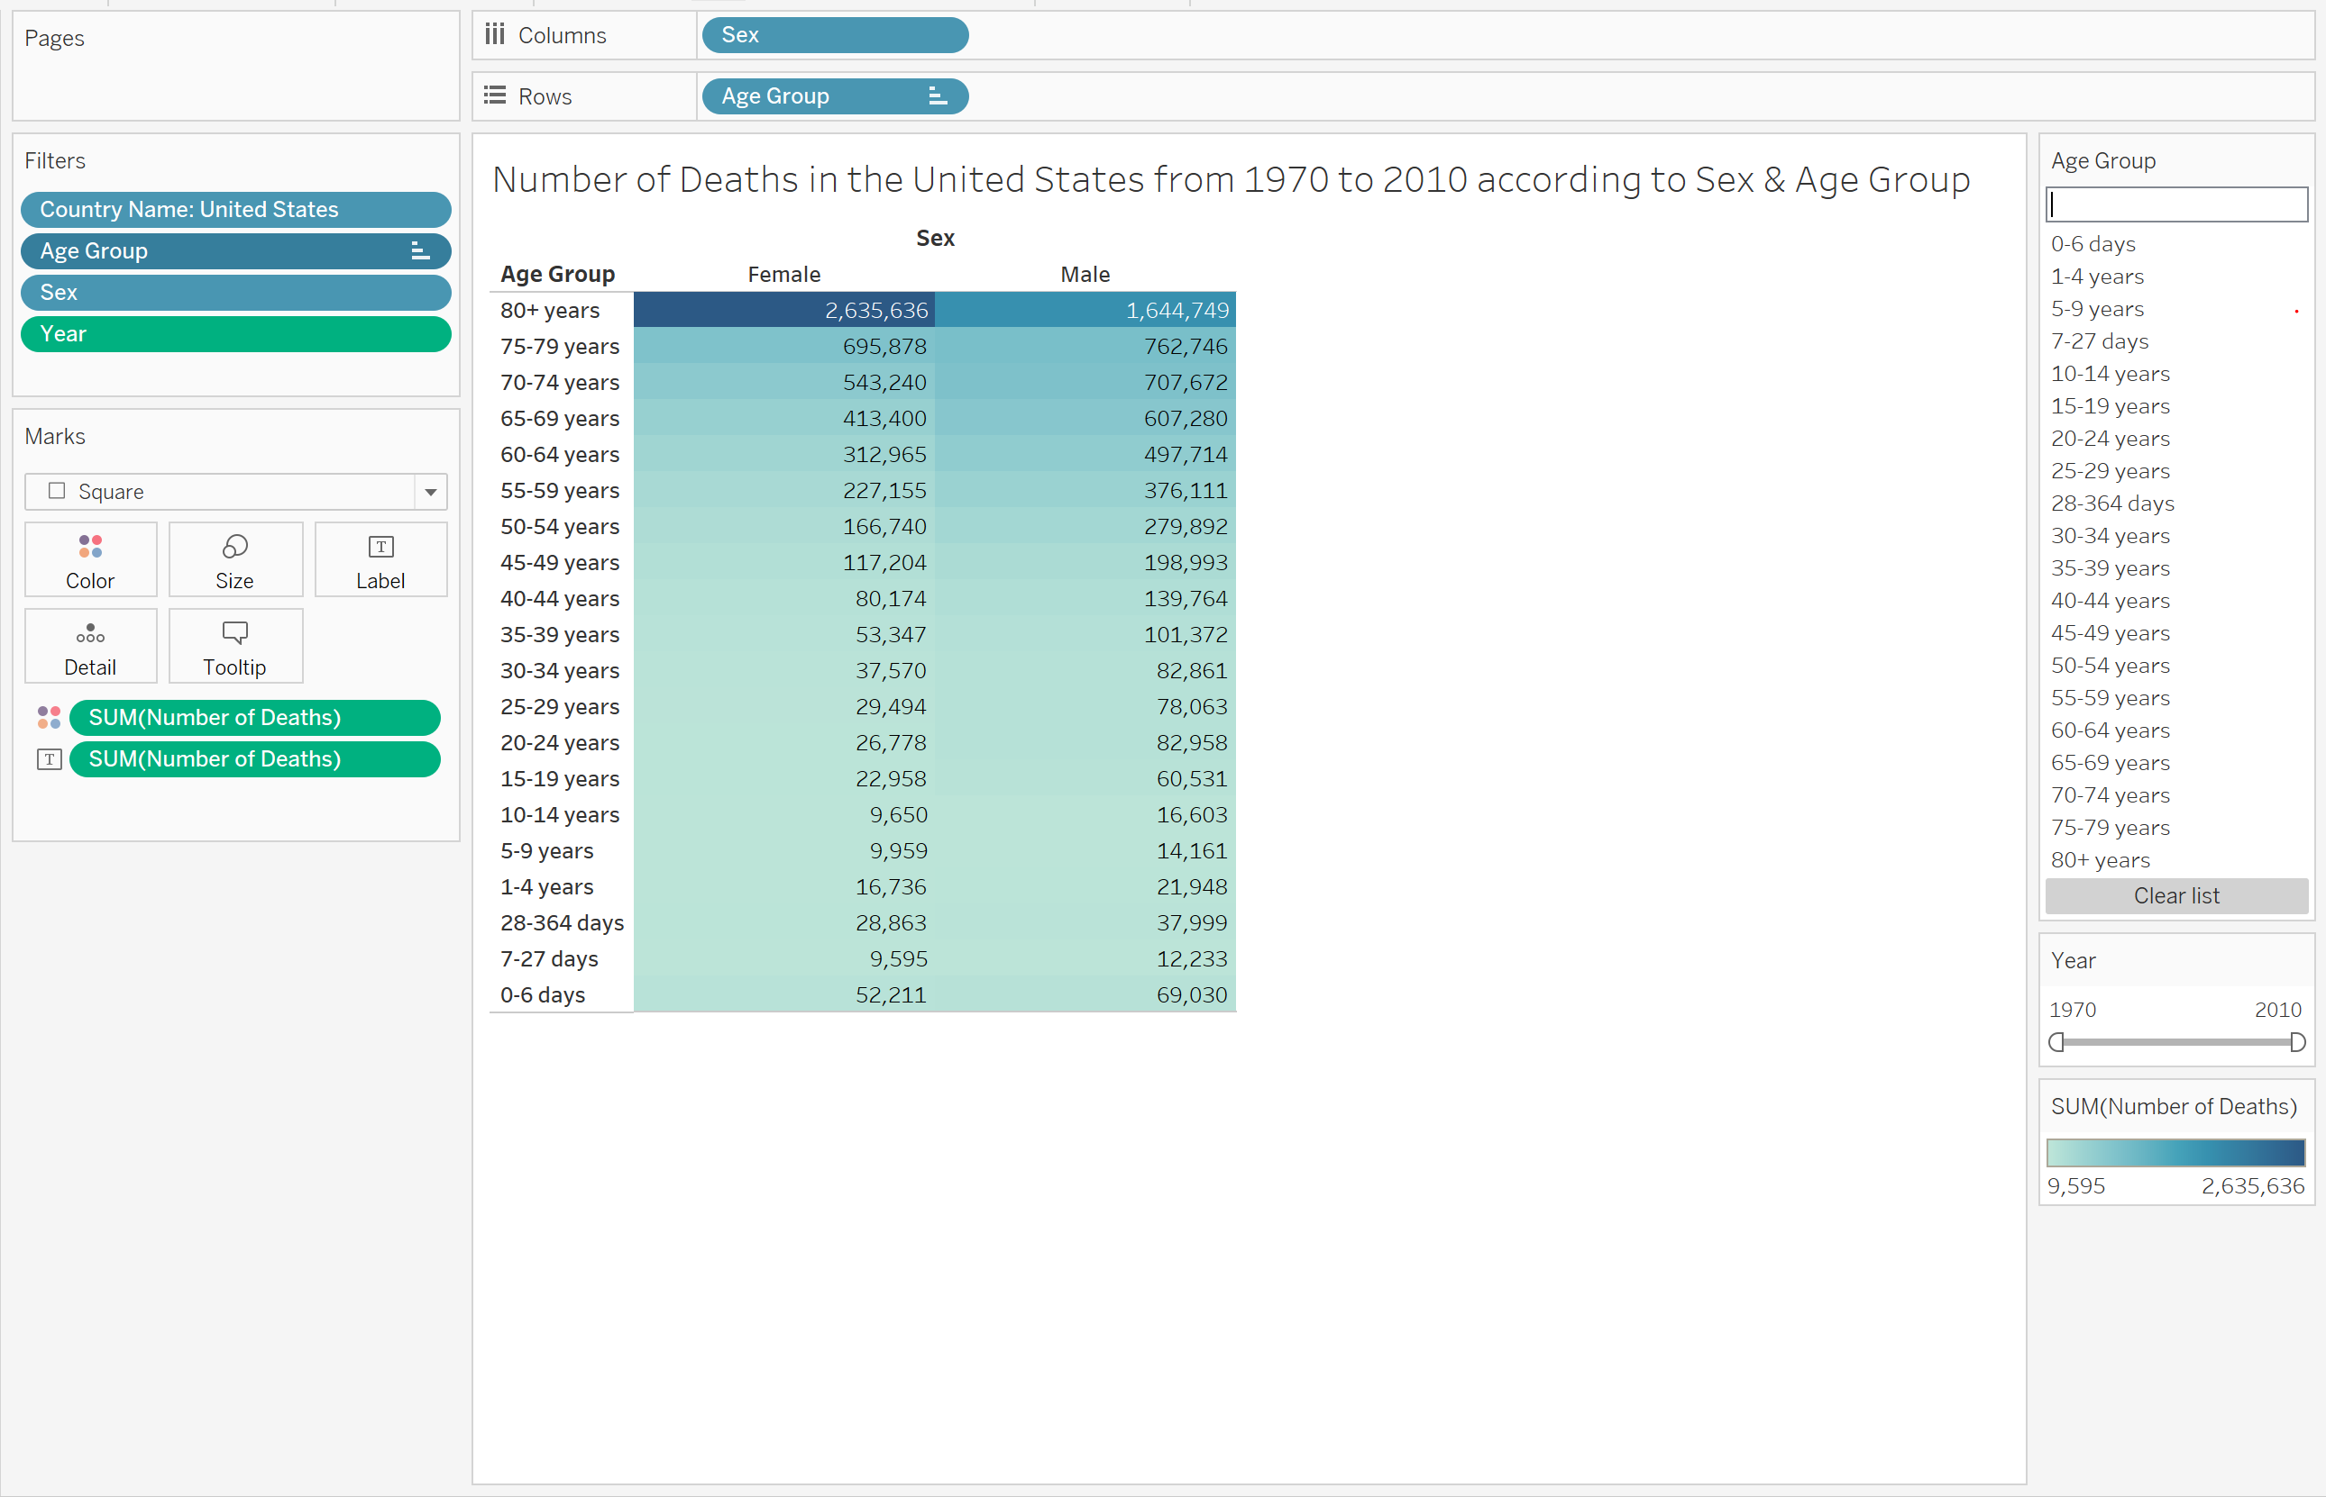

Fig1 Caption: Number of Deaths in the U.S. from 1970-2010 according to Sex & Age Group

Paragraph: For this chart I wanted to answer the question “How do the number of deaths compare from Men to Women in the U.S.”. So I filtered the country name so that it would only be the United States. From there I made sure to have the visualization be over the whole time period and that it would compare male and females together. I think that this graph answers that question successfully because you can compare the two genders over each age group. For instance, we can see that once females and males are over 80+ years old, there is a significant jump in the number of deaths in females compared to males. Also, you can see from the ages of 65 to 79 that males have more deaths than women do. Lastly, the audience can directly see the numbers to compare age groups and the sex. Some things that can definitely be approved upon within this visualization according to the data visualization checklist, is the labeling for the age group. It is not in order from oldest age to the youngest age. From there I would also add some text to showcase the meaning of this visualization and also pick a different color palette to drive home the differences not only between ages but also between genders. Finally, I would try to make the title smaller and more concise so that it hooks the audience at first and then they can find more information below the title in a subtitle.

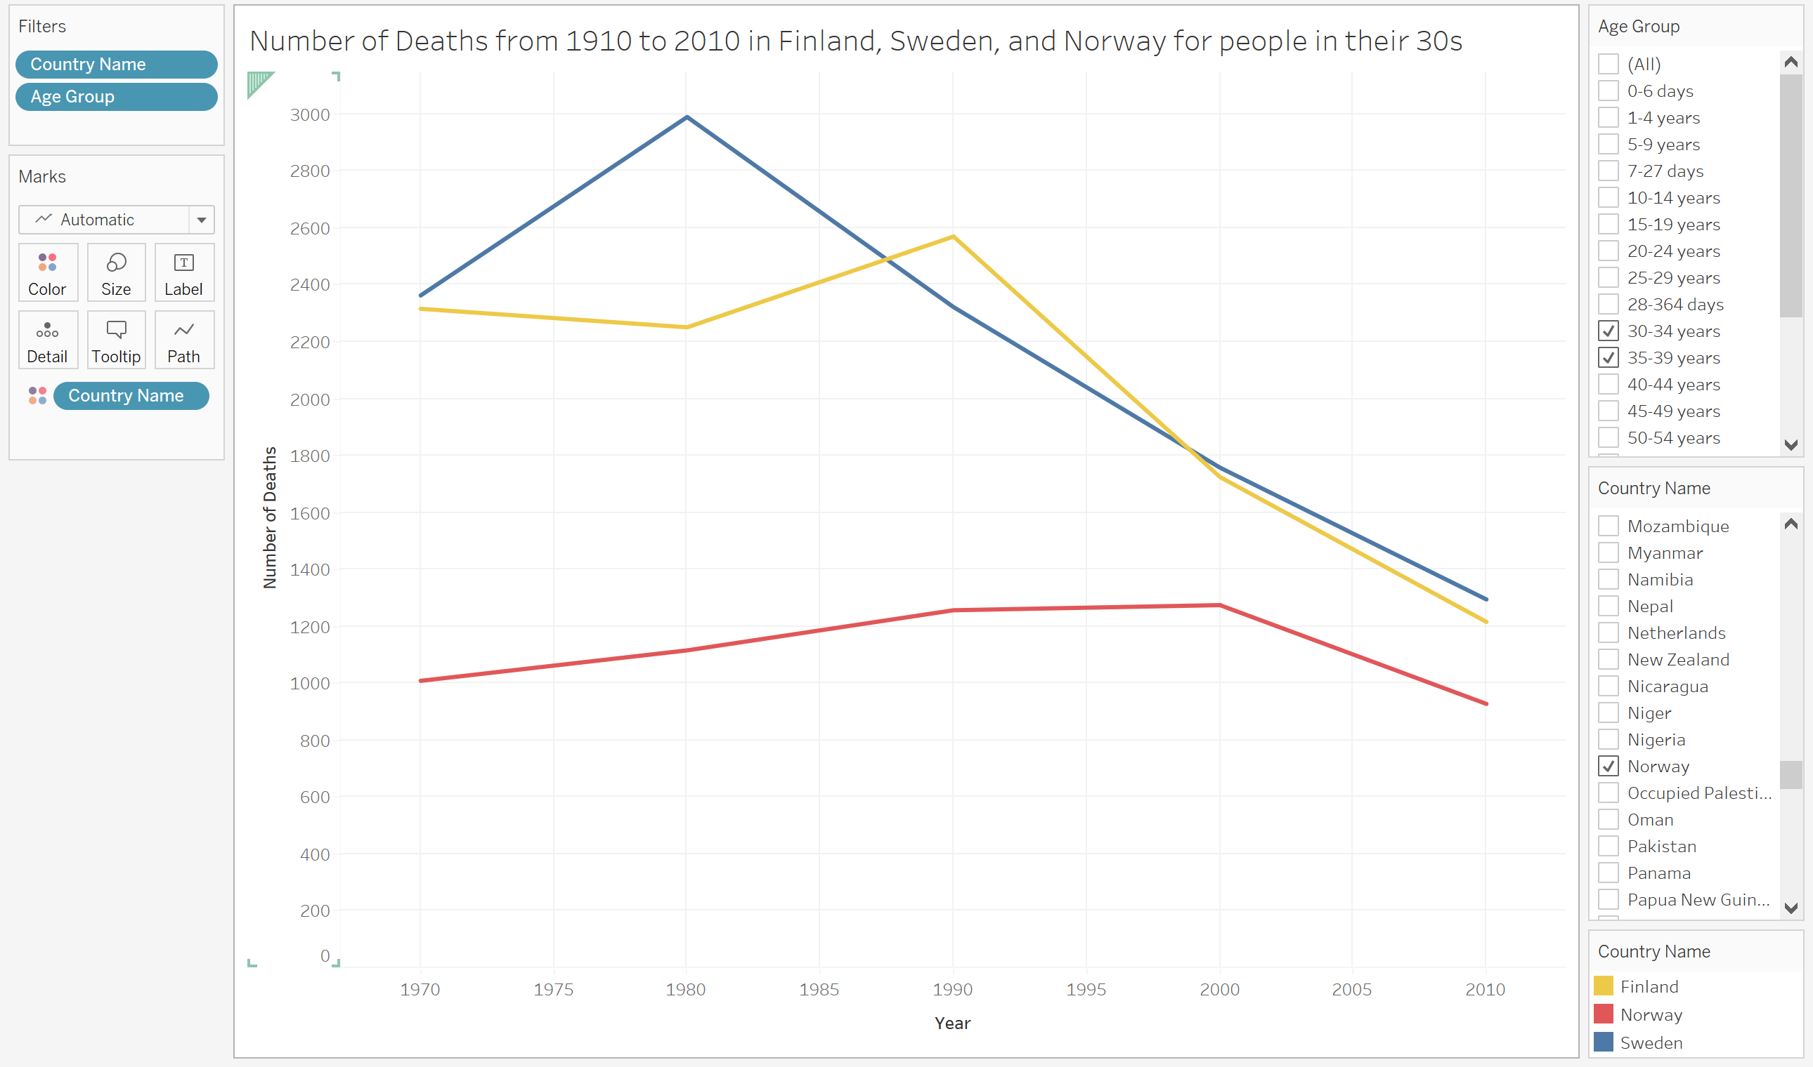

Fig2 Caption: Number of Deaths from 1910 to 2010 in Finland, Sweden, and Norway for people who are in their 30s.

Paragraph: The question that was trying to be answer here was “What is the total number of deaths look like in Northern European Countries for citizens between 30-40 years old ?”. I first started by filtering the countries to only include Finland, Sweden and Norway so those are the most Northern European countries. From there I next filtered the age groups so that it was only from 30 years old to 39 years old. I tried to give the line chart contrasting colors to make the chart be as easily readable as possible. Also, I made sure to showcase the filters on the right, to prove that I am filtering based on the correct age and country. I support this visualization because we can clearly compare the countries over the time period and see the Norway from 40 years has continued to have lower number of deaths compared to Finland and Sweden. We can now take a look at other datasets to see why this is. We can also look into if the geography and where the population is located has a factor into this difference. Looking at the data visualization checklist there are definitely areas of improvement. For example, you have to look all the way down in the right corner to see what each of the different colors mean on the line chart. Also, there is no subtitle or annotation to provide additional context or information to the user. Finally, some of the labels are horizontal and this chart does not reinforce any overarching takeaway message. In the future, I will definitely add more text or meaning to drive home the point of this visualization.